Youtube Video: https://youtu.be/9bsVQvp92-s
Github Link: https://github.com/KiribosBriskit/DAGV-Projects

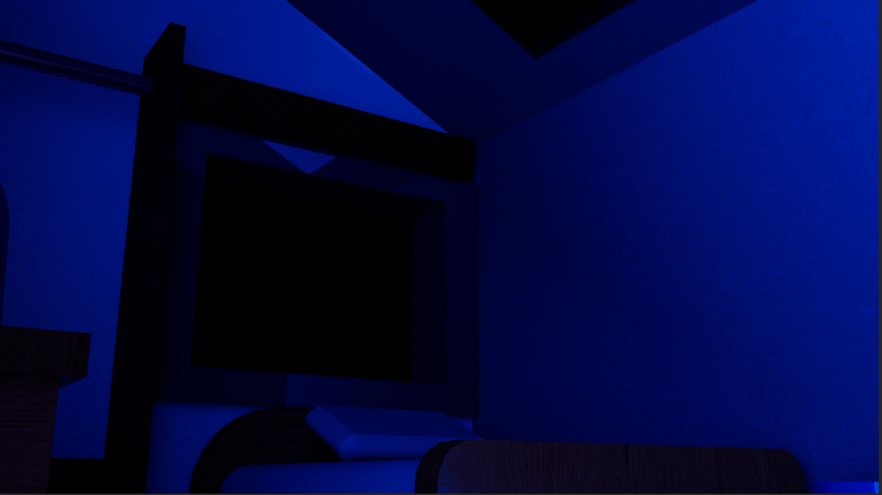
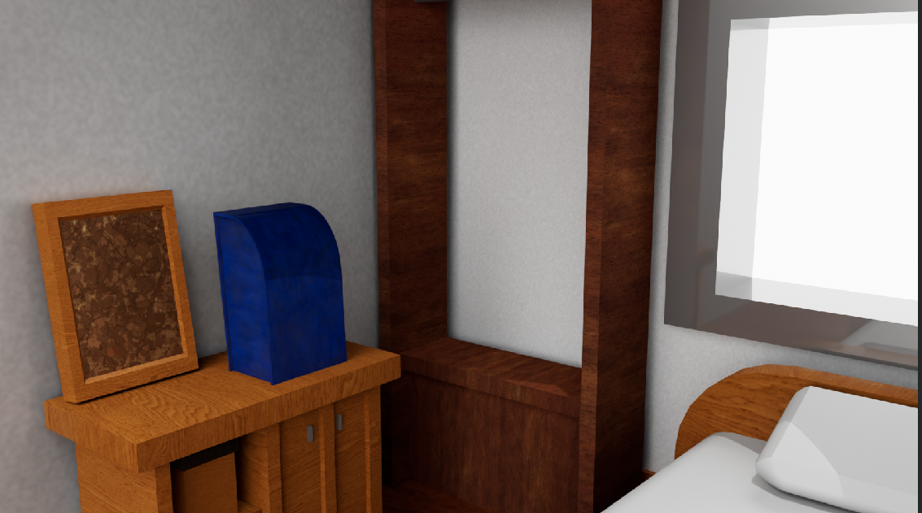
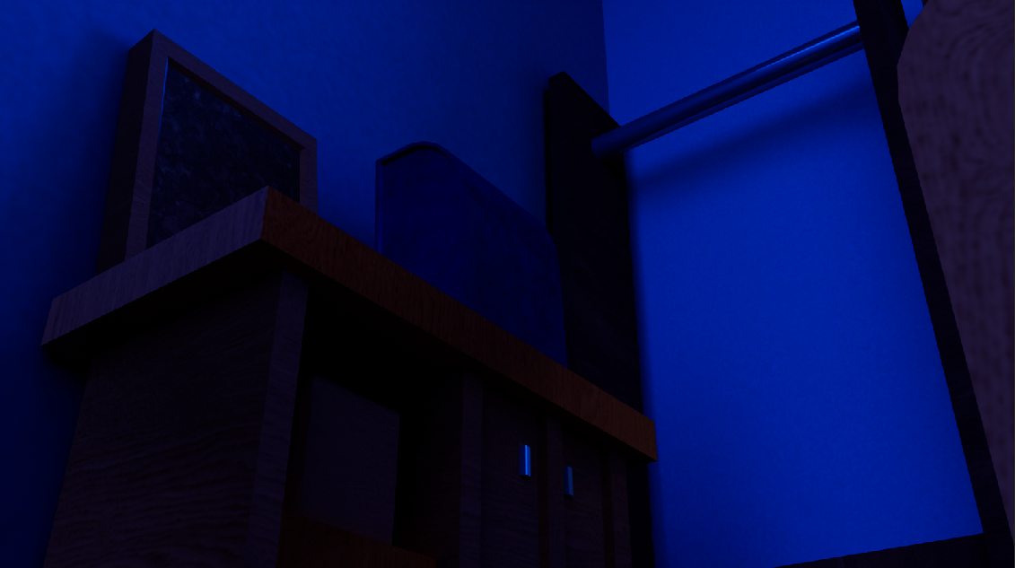
One of the ways I ensured consistency across props was to make sure I was using the same consistent material across props or objects where it would make sense to have the same material. Walls, for example, use a similar texture used in Substance Painter. However, I probably kept some things too consistent. The wood on the corkboard and box probably shouldn’t have shared the exact same wooden material as the shelf, for example. I think the blue lighting I used worked well to convey the feeling, or have it easily read, that it was late at night, while still keeping everything viewable in the first place. Realistically, it’d probably have more dimmer light, but you just wouldn’t see anything. Plus it allowed me to be a little lazy with the lighting. 2 things I would improve if I had more time: the shelf was missing some manga. In the original reference, at another angle, some manga were stored in the shelf. I think something like that would’ve given the scene a lot more life, feel more lived in if there was a more personal touch in the setting, but I didn’t feel like figuring out how to texture something like that. I also want to put more time into the backpack. The reference simplifies the backpack design by a lot in comparison to real life photos of backpacks, and I think it would read better as a backpack if I did the straps.

